Content Script: FutureLearn
Course title: Writing About Music
Weeks:
Week 1: Sonic environments – What is critical listening?

Table of contents

Week 1: Sonic environments – What is critical listening? 3
1.1 Welcome from Ariana 3
1.2 Listen up 6
Activity 1: What’s that noise? 8
1.3 Listening to your environment 9
Video script: Listening to your environment 11
1.4 What does sound actually sound like? 16
Video script: Describing music our way 18
Summary 20
1.8 Summary 20
1.9 Glossary 21

Week 1 | Week 1: Sonic environments – What is critical listening? | 
Description  (Max characters 230, inc. spaces) | This week, you explore ‘critical listening’ and are introduced to the range of technical and figurative language that you’ll encounter during this course. You begin by discussing your favourite music with other learners.

Step no. | 1.1 | Duration | 10 minutes
Format | Article | Learning type(s) | ACQUIRE  DISCUSS
Title | 1.1 Welcome from Ariana
Description  (from Course Outline) | Text  Learners are welcomed with a high-level overview of what they will learn and produce during the course. This includes exploring what it means to listen critically, ways of understanding and evaluating what they hear, and how to begin developing their own style of writing – the key focus of this course. Learners also consider how the language used to talk about music can shape their thoughts about a piece.  Learners are reminded that music is personal and often emotive. There is no right or wrong way to feel about a piece. However, the course also introduces them to some helpful tools and frameworks for communicating their experience to others.  The course also equips learners with transferable skills that can be applied in a range of music disciplines, both at university and beyond. They hear from students and alumni about the value of learning to write about music.  In a short section on ‘working constructively in an online space’, learners are introduced to the course’s assessment types, the level of educator presence they can expect, and that they will engage in peer discussion. Learners are reminded that giving and receiving feedback are core skills developed during study at university. During this course, learners will be encouraged to bring their own subjective opinions and voice to the discussion. When discussing music with peers, learners are expected to be respectful and show interest in the views of others.  Learners are encouraged to make their own notes throughout the course. These notes will be helpful both for the written activities in this course and for further study.  Comments section  Learners introduce themselves in the Comments section and recommend to other learners a piece of music they enjoy. Learners are also encouraged to expand their critical skills by listening to a new or unfamiliar genre/ a peer’s recommendation and comment on their experience.
Content (include references to any images, documents or links you wish to include)
Have you ever wondered how to describe what happens in the music you enjoy? Or tried to convince someone else that they should listen to your favourite artist?

Perhaps you’re a songwriter who wants to understand more about the interaction of words and music, or you’re curious about a career in music journalism. Perhaps you simply want to develop your skills in writing about music. Whatever your pathway, this course will help you achieve your goals.

Welcome to Writing About Music.

I’m Dr Ariana Phillips-Hutton, Lecturer in Global Critical and Cultural Study of Music at the University of Leeds. As your Lead Educator, I’m excited that you’ve decided to join us.

<Image – WrAM-IMG-001>Headshot of Dr Ariana Phillips-Hutton.

You’ll begin by learning to listen critically to the sounds that surround you every day. Next, you’ll develop skills for understanding and evaluating what you hear, putting these skills into practice by producing short pieces of writing about music. You’ll also have the opportunity to engage with writing from other learners.

There isn’t one ‘right’ way to write about a piece of music (referred to as a ‘piece’ or ‘track’ within this course), but as you participate in the included activities, you’ll begin to develop your own style of writing. Ultimately, this course is about communication: how can we best understand the music that we like (or don’t like) and share it with others?

The tools and practice in listening, thinking and writing about music you’ll gain will enhance your preparation for studying music. They will also equip you with key transferable skills that you can take with you wherever you go.

“I find that music is a very expressive and moving medium. To be able to articulate what it means for you in terms of your culture, or how a genre has evolved throughout history, is a wonderful gift to share with people.”
Lois Chapman
Student, MA Music and Music Psychology
University of Leeds

“I think that music is a topic that impacts every single person. Whether you've got negative or positive memories, you had a nice time in ensemble class, or you listen to to it when you’re going places, everyone’s impacted by music. By learning to write about it, we expand what we know about music and also expand the landscape of what we can do with it.”
Isabelle Lawes
Student, BA Music
University of Leeds

“There’s an enormous value in learning to write about music. I suppose the most significant value is being able to understand music in new and different ways, and ultimately, to be able to listen in different ways and hear things that otherwise wouldn't be possible.”
Ed Cooper
Alum, Undergraduate, Masters and PhD degrees
University of Leeds

“The value of learning to write about music is that it helps create a sense of wonder. It helps create curiosity for any topic that I’m reading up on because of the incidental information and knowledge that I’m able to pick up.”

Japjisingh Valecha
Alum, BA Music (Hons)
University of Leeds
Learning outcomes
By participating in this course, you will be able to do the following:
- Develop skills in critically evaluating music.
- Identify reference materials that help shape your opinions about music.
- Explain your own views about music confidently.
- Apply transferable academic skills of critical listening and academic writing about music.
Making the most of your learning
Writing About Music is a self-paced course, but you should expect to spend approximately two hours each week preparing materials and working through the activities. As you participate, consider making your own notes about what you’re learning – you’ll find this useful both for the included written activities and for any further study you might do.

The Course Map in the Downloads section provides an overview of the four weeks ahead.

<Image – WrAM-IMG-002>Montage of interactive activities and videos from the Writing About Music course.

You’ll have opportunities to test your knowledge of concepts and terminology, and to compare your critical listening with what others hear in the same example. You’ll also engage in peer discussion, giving and receiving feedback on written work. It can feel intimidating to share your opinion or your work with others, but this is a key skill for university study. Everyone’s opinion and voice is valuable, so listen with an open ear and mind.

If you enjoy this course, you may also want to check out the ‘Music as Sound’ course from the University of Leeds.
Accessing music tracks
For educational purposes, Writing About Music includes analysis and critiques of commercially available music tracks. These are hosted on YouTube and are embedded within the learning content of this course for ease of access. Where possible, music that is out of copyright has been selected.

If you’re unable to access YouTube in your country, search for the track by name using an alternative video or audio streaming platform.

Get started

Introduce yourself to other learners in the Comments section by sharing the name of a piece of music you enjoy listening to. You may even want to check out another learner’s recommendation and comment on how their chosen piece makes you feel.
Notes and assets
(videos, interactives, links and downloads)

Step no. | 1.2 | Duration | ?
Format | Article | Learning type(s) | ACQUIRE  INVESTIGATE
Title | 1.2 Listen up
Description  (from Course Outline) | Text/image  Learners see a profile image and quote from the educator talking about how the ability to listen to music and communicate this to others has helped them in their career.  Music clip/text/images  Learners are invited to ‘open their ears’ by listening to a short musical excerpt (approximately 30 seconds). Then they read a short paragraph of the above educator saying what they hear in it, and quotes from two others (ideally students/alumni) drawn to different elements of the song (e.g. vocals, bass, rhythm).  Learners are encouraged to listen again for something different. They are reminded that this course will equip them with the skills to listen critically and effectively communicate what they hear.
Content (include references to any images, documents or links you wish to include)
“Writing about music is said to be pointless, like dancing about architecture, but being able to listen critically to music – and to describe what I hear to others – has made me a better musician and a better communicator.” – Dr Ariana Phillips-Hutton.

<’Media’ button embed>YouTube video – Joni Mitchell, ‘A Case of You’ 0’19”–0’39” https://www.youtube.com/watch?v=qAZp5JfDmz4; needs to be one of the recorded versions, not live. 2021 remaster and original have same timings.


Take a few moments to listen to the track above from 0:19 to 0:39. Use the video player’s seek function to locate the timecode. Make a note of what you hear using whatever language you feel most comfortable with.

After listening to the track, read the following observations.

“One of the things I notice immediately is the rhythm and pacing of the vocal line in relation to the instrumental texture. The simple guitar backing that underpins the song seems straightforward, but there’s a wonderful fluidity in Mitchell’s vocals that creates layers of meaning.
For example, the sudden tumbling forward of the lyric ‘I am as constant as a northern star’ tells us that the character is lying – or maybe self-deluded – because these erratic rhythms are anything but constant.
Likewise, the lengthy held note on ‘bar’ suggests that the singer not only went to the bar, but has stayed there, waiting, for someone who never showed up. The detailed level of interpretation within the rhythm, or flow, of the vocal line is a subtle, but crucially important, part of interpretation.”

Dr Ariana Phillips-Hutton

<Image – WrAM-IMG-003>Headshot of Chiron Leather.

“I think the vocal line is a really key part of the track. It’s very raw – not too much has been done to it. Initially it’s very stepwise, very straightforward, but then as the song develops, as we move further through the music, you hear more ornamentation and a lot more melismatic ideas.”

Chiron Leather
Student
BMus Music (Performance)

<Image – WrAM-IMG-004>Headshot of Lois Chapman.

“When the solo guitar and her vocals come in, she sounds quite bittersweet in how she sings the lyrics. She’s talking about a love lost, and you can hear that in how she expresses the lyrics, especially when she sings, “if you want me I’ll be in the bar”. You can hear that sense of loss in her voice. The guitar is quite melancholic in terms of how it’s major, but you can hear the bittersweet nature of it.”

Lois Chapman
Student
MA Music and Music Psychology

How do the three observations above compare with what you heard? Don’t worry if you didn’t hear the same things – there isn’t one ‘right’ way to hear a track. As you participate in the course, you’ll spend time developing your critical listening skills and learning how to express your views so that others can hear alongside you.

<Image – WrAM-IMG-005>A student listens to music using wireless earbuds.
Listen again
Now you’ve read what Ariana, Chiron and Lois heard in this excerpt, listen to the clip again. This time, focus on something different from what you heard the first time. Add to your notes using the following questions as prompts.
- What do you notice about the piece this time?
- How does listening ‘for’ something in particular change your overall experience?
Before moving on to the next step, take a moment to reflect on the kinds of things you might now typically notice when listening to music.
Notes and assets
(videos, interactives, links and downloads)

Activity 1 | Activity 1: What’s that noise? | 
Description  (Max characters 230, inc. spaces) | Critical listening, or understanding and evaluating the sounds that you hear, is at the centre of musical study. In this activity, you explore this concept and engage with some everyday applications of critical listening.

Step no. | 1.3 | Duration | 20 minutes
Format | Video | Learning type(s) | ACQUIRE  INVESTIGATE  PRODUCE
Title | 1.3 Listening to your environment
Description  (from Course Outline) | FutureLearn-hosted video (for full accessibility)/YouTube-hosted 360 video (for enhanced learner experience)  Learners then watch a video that serves as an introduction to the concepts of critical listening, understanding and evaluating soundscapes.  The educator appears in an environment, such as a park, where there are background sounds including music. They explain that if we pause to listen to our environment, we start to notice sounds that we may not have paid attention to, and that there are frameworks for describing some of these sounds. The narrator then pauses to enable learners to listen to the park.  Learners are asked to identify and describe what they heard before the educator shares a model answer.  Learners are encouraged to think about the fluid boundary between ‘sound’ and ‘music’. The educator explains that while not all sounds are ‘music’, we can describe the musical features of some sounds. Starting with the broadest category, ‘sound’, the narrator then narrows the focus to ‘musical sounds’, giving audible (or audio described) examples of each. The narrator then draws the learner’s attention to the narrowest category, ‘music’, which is identifiable in the foreground.
Content (include references to any images, documents or links you wish to include)
<Video>Listening to your environment (non-360° version) – WrAM-VID-001.

In this video, Ariana presents a critical listening exercise in St George’s Field and Hyde Park, Leeds.

You’re encouraged to listen carefully, observing and reflecting on the sounds you hear within the sonic environment. As you listen, Ariana offers her own observations and introduces you to frameworks for describing some of these sounds.

If you have access to YouTube, you can watch a 360° version of this video.
The sonic environment
Wherever you are, whether you’re awake or asleep, sound waves are constantly bombarding your ears.

Unlike closing our eyes to shut out visual images, we don’t have the ability to close our ears – at least, not without using our fingers or earplugs. However, despite being constantly surrounded by sound, we don’t necessarily listen to it.

In fact, we can’t listen to everything – not just because the extent of human hearing is quite average in comparison to the hearing of other species, but because, well, the world is loud.

<Image – WrAM-IMG-006>Headshot of George Eliot, a 19th-century writer.

The 19th-century writer George Eliot used the metaphor of sensitive hearing to describe the limitations of human understanding. She writes:

“If we had a keen vision and feeling of all ordinary human life, it would be like hearing the grass grow and the squirrel’s heart beat, and we should die of that roar which lies on the other side of silence.”

Ariana’s response:

“I like the way Eliot makes me imagine what it would be like to hear the plants grow or to be alive to every being around me, but I think that if I ever gained that ability I would need some very good headphones!”

So, sound is everywhere, but we don’t always listen to it, either because we can’t hear it or because we choose to shut it out (perhaps with the help of those headphones I mentioned). But what happens if we start to pay attention to particular sounds?
What is a soundscape?
<Image – WrAM-IMG-007>Headshot of R. Murray Schafer, a Canadian composer.

In the early 1970s, the Canadian composer R. Murray Schafer coined the term ‘soundscape’ to describe all of the sounds that exist in a particular place.

In the same way that you might have visited somewhere to look at a particular landscape or ‘view’, we can start to notice individual sounds in our soundscape that we might not have otherwise paid attention to. This is the first step in what we call ‘critical listening’.
Notes and assets  (videos, interactives, links and downloads) | See also section  - Listening to your environment 360° video  YouTube

Step no. |  | 1.3 | Duration | 879 words (22/11/24 edit). Approx. 5 minutes and 52 seconds, if averaging 2.5 words per second.
Asset number |  | WrAM-VID-001
Title |  | Video script: Listening to your environment
Format |  | 360º video
Speaker(s) (full name, title, role and affiliation to be displayed on screen. 15 words each max.):

Dr Ariana Phillips-Hutton
Lecturer in Global Critical and Cultural Study of Music
School of Music
Description  (from Course Outline) |  | Learners watch a video that serves as an introduction to the concepts of critical listening, understanding and evaluating soundscapes. The educator appears in an environment, such as a park, where there are background sounds including music. They explain that if we pause to listen to our environment, we start to notice sounds that we may not have paid attention to, and that there are frameworks for describing some of these sounds. The narrator then pauses to enable learners to listen to the park.  Learners are asked to identify and describe what they heard before the educator shares a model answer. Learners are encouraged to think about the fluid boundary between ‘sound’ and ‘music’. The educator explains that while not all sounds are ‘music’, we can describe the musical features of some sounds. Starting with the broadest category, ‘sound’, the narrator then narrows the focus to ‘musical sounds’, giving audible (or audio described) examples of each. The narrator then draws the learner’s attention to the narrowest category, ‘music’, which is identifiable in the foreground.
Script |  |  | Direction/Images/Captions/B-roll
Location 1: St George’s Field
1. | Hello. Welcome to St George’s Field here in Leeds on this autumnal day. In this video, we’ll consider the relationship between sound and music. Specifically, we’ll explore the concept of critical listening by understanding and evaluating a particular soundscape. |  | Display lower-third.  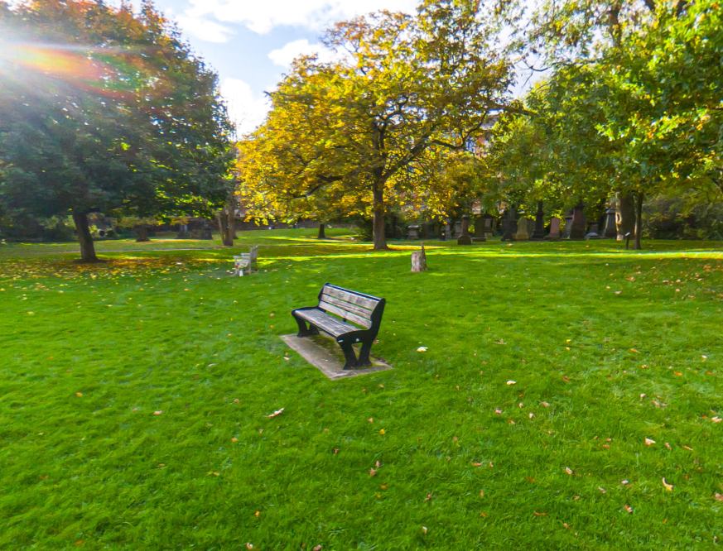  Ariana sits on a bench or step, addressing the learner directly through eye contact with the camera.
2. | So, take a moment now and listen with me to the soundscape. What do you hear? <Allow time for learners to listen to the soundscape before they’re asked to pause the video> |  | Sounds to include at this point:  - Music coming from a portable speaker  - Chatting  - Skateboard  - Traffic  - Building vents  - Birdsong
3. | Now pause the video and take a moment to identify and describe some of the sounds you noticed. <Brief pause> There are actually quite a few different sounds going on here today. Firstly, I can hear the hollow scrapes of the skateboard as its wheels rattle across the tarmac. I can hear a monotonous rumble coming from the extraction vents of a nearby building, mixed with the distant, dull roar of traffic. |  | Ariana to camera.  Refer to Slide 2 of Matt W’s PowerPoint presentation for locations.
4. | As people begin to gather over there, I can hear the bubble of laughter and enthusiastic conversation. <Brief pause> It’s quite subtle today, but despite the pumping – but muted – beat of the track coming from a portable speaker, I can also just about pick out the sweet sound of birdsong.
5. | Now, you may be thinking to yourself, “but these are just noises, what does this have to do with learning to write about music?” And that’s a reasonable question, but in order to write about music, you have to first be able to distinguish what you’re hearing.
5. | Humans have an average sense of hearing. Well, at least, that’s true in terms of the range of frequencies that we can hear, but humans are actually very good at distinguishing one sound from another. This helps us differentiate between speech and singing, or between the sounds of individual voices, or between the cat yowling in our back garden and the dog barking next door.
6. | Now let’s visit nearby Hyde Park and listen to what sounds we can hear there. |  | Crossfade to new location.
Location 2: Hyde Park ‘circle’
7. | While it might seem at first that there are some sounds that are ‘noises’ and others that are ‘music’, this is a boundary that shifts based on your perspective. Birdsong is a good example of this: it has a reputation for being ‘musical’ and is often quite beautiful – certainly, people have written many pieces of music that imitate birdsong. |  | 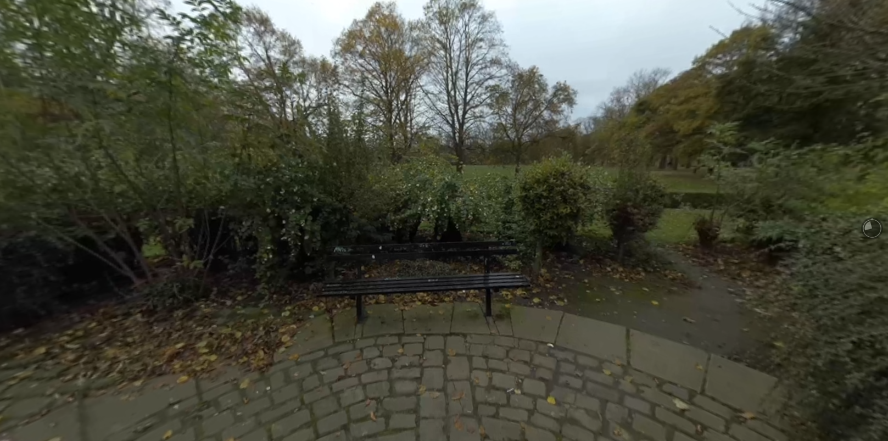  Sounds to include at this point:  - Birdsong  - Chatting  - Traffic  - Siren
8. | At the same time, anyone who has been startled by the harsh call of a crow, or been irritated by the cooing of a pigeon, or even been woken up by a determined ‘dawn chorus’ may hear birdsong as noisy rather than musical.
9. | But even when sounds aren’t, strictly speaking, ‘music’, we might be able to describe some of their features as musical. For example, birdsong moves up and down in pitch (a term that describes the highness or lowness of a sound), thereby creating a line that we might call a ‘melody’. It also often uses short fragments – which we might call ‘phrases’ – and repeats them, generating a sense of rhythm. These are characteristics of human songs, too, and help to give music structure.
10. | Returning to the birdsong, here we might focus in further on the quality of the sounds themselves: perhaps you might describe a given sound as ‘bright’ or ‘soft’ or even ‘dark’ – these words are commonly used to describe what we call musical timbre or tone colour.
11. | Timbre is difficult to define, but it refers to one of the ways you can distinguish between the sound of, for example, your mother and your grandmother, or between the saxophone and the trumpet, or between the rumble of a lorry going past or thunder in the distance.
12. | Let’s now have another listen a final location, again, here in Hyde Park. |  | Crossfade to new location.
Location 3: Hyde Park ‘square’
13. | There are all kinds of sounds around you that you might think about in musical terms. But in the modern world, we are surrounded by music, too. Listen again to the sounds in the park. Can you hear the music? <Brief pause, with music foregrounded in the mix>. |  | 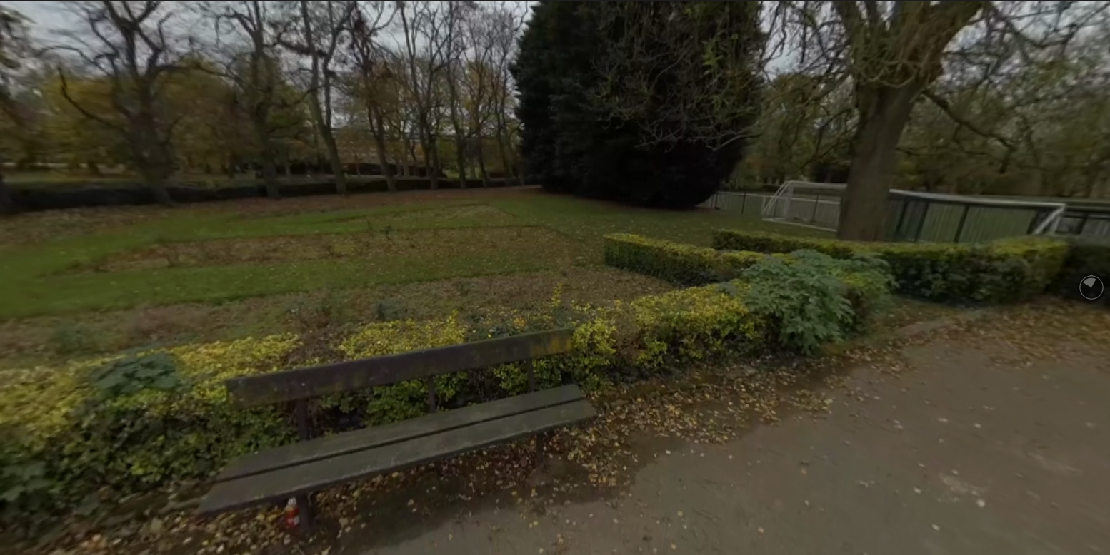  Sounds to include at this point:  - Music  - Chatting  - Tennis court  - Traffic  - Birdsong  - Helicopter
14. | The music here has a melody, it has repeated sections, and it certainly has rhythm – in this, it shares many of the same features as the birdsong we have been talking about. However, of course, it has a lot more going on than just these features, and if we listen critically, we can start to hear these emerge.
15. | Listen for a few more seconds and think about how you might describe this music. You may then want to pause the video and write down some notes to help you remember. <Brief pause>.
16. | Keep this idea in mind: you exist in a soundscape that surrounds you wherever you are, that is constantly changing, and that includes all sorts of sounds – whether these are ‘noises’, ‘music’ or something in-between. Opening your ears to a variety of different sounds and, more importantly, thinking about how you might describe them is not only important for articulating what it is that you’re hearing. It can also change your perspective on the relationship between words and music.
17. | Of course, the pounding of rain on the roof isn’t quite the same as the pounding beat of dance music played in a nightclub. However, by choosing to describe these features using a word such as ‘pounding’, you can help your reader understand what it is that you are hearing. It can also give them a sense of what they might experience if they were to hear it too.

Step no. | 1.4 | Duration | 10 minutes
Format | Discussion | Learning type(s) | DISCUSS
Title | 1.4 What does sound actually sound like?
Description  (from Course Outline) | Discussion  In this discussion step, learners are asked to reflect on the previous activity. Comparing their answer to the model answer provided, they will respond to questions such as:  - How many of the educator’s observations did you hear?  - What challenges did you encounter when describing these sounds?  ‘Have a go’ prompt: Using lessons learned from the previous step, learners are encouraged to pause and listen to the sounds around them, posting what they can hear in the Comments section.  They are encouraged to use other learners’ comments to prompt an even closer listening to their own environment – is there something they missed the first time?
Content (include references to any images, documents or links you wish to include)
In the previous step, you had the opportunity to listen critically to the soundscapes in St George’s Field and Hyde Park.

<Image – WrAM-IMG-008>Screenshot taken from the video of the park soundscape in Step 1.3 Listening to your environment.

Take a few moments to reflect and make notes about what you heard and how you decided to describe it. Consider the following questions to help guide your note making:
- What sounds stood out to you the most?
- How would you describe these sounds?
Now read the following paragraph from Ariana, comparing your notes with hers.
Ariana’s interpretation
“In St George’s Field, the most prominent sounds I heard were human created. For example, closest to me there were people talking and laughing together, with the pitch going up and down, punctuated by the regular hollow thump of a football being kicked around. At one point, a bike bell rang out across the park as a warning to some pedestrians. Of course, there was the dull roar of an extractor fan and the murmur of the music being played over some portable speakers.

There were fewer people around in Hyde Park, and this meant that I could hear quite a lot of birdsong, including a rather noisy crow. Traffic from the nearby road was audible too, but I only noticed it when I listened carefully or when a particularly noisy vehicle came past. Many of the sounds were things I hear regularly, but I don’t usually listen to them or pay attention to how they interact.”

Consider your responses to the following questions:
- How many of Ariana’s observations did you hear?
- What challenges did you encounter when describing these sounds?
Your own soundscape

Now it’s your turn. Using what you’ve explored about soundscapes in the previous steps, take a listen to your own surroundings – remember to remove headphones if you’re wearing them. Share what you’re able to hear in the Comments section.

Next, read what other learners have written about their sonic environments. Which parts of their descriptions prompt you to think further about your own soundscape?
Notes and assets
(videos, interactives, links and downloads)

Step no. |  | 1.7 |  |  | Duration
Asset number |  | WrAM-VID-002
Title |  | Video script: Describing music our way
Format |  | Talking heads with b-roll
Speaker(s) (full name, title, role and affiliation to be displayed on screen. 15 words each max.):

Dr Ariana Phillips-Hutton  Lecturer in Global Critical and Cultural Study of Music  School of Music |  |  | Lydia-Faith Smith  Student  BA Music and Music Psychology | Chiron Leather  Student  BMus Music (Performance) |  | Ed Cooper  Alum  Undergraduate, Masters and PhD degrees
Description  (from Course Outline) |  | Learners listen to educators, current students and alumni describing their favourite pieces of music using a mixture of figurative language (e.g. slithering) and technical vocabulary. As they listen, learners are encouraged to notice the technical and figurative language used by the speakers.
Script |  |  |  |  | Direction/Images/Captions/B-roll
1. | Introduction from Ariana. In this video, …
Ariana’s choice: ‘You Want It Darker’ by Leonard Cohen
2. | The opening is a luminous choir singing in harmony on ‘ooh’ in this arching phrase before the electric bass and drum kit come in with a laid-back groove. At least, it sounds laid back, but the light offbeat taps on the hi-hat sound almost like the ticking of a clock – one beat every second – which quickly morphs into something threatening. |  |  |  | Display lower third as per detail in speaker field above.
3. | When Cohen’s voice comes in, there is almost no melody to speak of. He is really speaking, rather than singing, and his voice is just a growl at the very bottom of his baritone register.
4. | The whole song is a meditation on death written by a man at the end of his life. It isn’t the most cheerful piece, but the first time I heard it, the combination of that angelic chorus, the smoky, damaged vocals, and the inexorable tick of the hi-hat clock stopped me in my tracks.
Lydia-Faith’s choice: ‘Green Eyes’ by Erykah Badu
5. | Content TBC. |  |  |  | Display lower third as per detail in speaker field above.
Chiron’s choice: Finale to ‘Symphony No. 8’ by Mahler
6. | Content TBC. |  |  |  | Display lower third as per detail in speaker field above.
Ed’s choice: ‘Two Slow Dancers’ by Mitski
7. | Content TBC. |  |  |  | Display lower third as per detail in speaker field above.
Summary
8. | Summary from Ariana.

Summary | Summary | 
Description  (Max characters 230, inc. spaces) | You have reached the end of Week 1. In this activity, you reflect on what you learned and look ahead to Week 2. You also have the opportunity to explore a glossary of terms that appear throughout the course.

Step no. | 1.8 | Duration | 5 minutes
Format | Article | Learning type(s) | ACQUIRE
Title | 1.8 Summary
Description  (from Course Outline) | Text  Learners are presented with a recap of the content for Week 1. They are reminded that using a mixture of technical and figurative language is important not only during this course, but in both in academic and commercial writing about music.  Learners read a one or two sentence summary of upcoming Week 2 content.
Content (include references to any images, documents or links you wish to include)
Critical listening, or the ability to identify what you hear, is the foundation for understanding and writing about music.

<Image – WrAM-IMG-009>Montage of images from the steps within Week 1 of the Writing About Music course.

This week, Ariana introduced you to the ‘soundscape’ – all the sounds you can hear in a given location. You then explored the distinctions between noises, sounds and music, and the ways in which our responses to these can vary based on our situation.

Paying attention to sound is only the first step, and in the second part of the week, you focused on developing your technical and figurative vocabulary to help you describe your own soundscape to others.

Remember, there’s a lot of variation in how we can describe sounds, so choosing appropriate words is crucial for communicating to your audience.

Sometimes, you’ll want to be precise, focusing on using technical language. At other times, you may be more interested in showing your reader how you experience sounds. In this case, figurative language will be useful. Much of the best writing about music demonstrates the skilful combination of both types of language.

These skills are crucial not only for this course, but also for writing about music in academic and commercial settings. Just for a personal reflection, take a few moments now to think about which example from this week has been the most interesting to you, and why.
What’s next?
In Week 2, you’ll focus on how to apply critical listening skills to writing descriptively about music. You’ll also have the opportunity to write and share your own description of a piece of music, and begin to develop your own ‘voice’.
Notes and assets
(videos, interactives, links and downloads)

Step no. | 1.9 | Duration | N/a
Format | Article | Learning type(s) | ACQUIRE
Title | 1.9 Glossary
Description
(from Course Outline)
Content (include references to any images, documents or links you wish to include)
We have included this Glossary for reference – you aren’t expected to remember all the new terms in this course.

You can refer to the Glossary throughout the course by returning to this step or by downloading the PDF version from the Downloads section.

If you come across any other words that you would like us to add to the Glossary, please add them in the Comments section.

Select the hyperlinked letters below (shown in pink) to jump to alphabetical sections of the Glossary.

A B C D E F G H I J K L M N O P Q R S T U V W X Y Z
Notes and assets  (videos, interactives, links and downloads) | [448] Writing About Music - Glossary.xlsx  Downloads section  - Glossary (PDF version)

